Christian Fronk

Lab 2 Report

Dr. Allen

First error: The first error Timmy made was in his constructor. Originally, he didn’t set maxSize in his attributes in his constructor, so I added a line to do so. 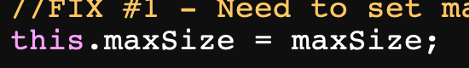

Second error: The second error Timmy made was not preventing getPos() from checking for a position that is out of range, IE less than zero or greater than the current size of the array. So, I added an if statement to make sure this would return false if attempted. I found this through my TestList.java file, through a test that tested the index -1. 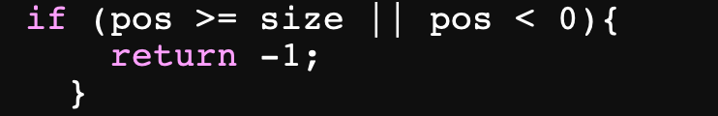

Third error: The third error Timmy made was in his remove() method. There was an if statement that didn’t have a size decrement inside of it, which is necessary to set the size of the array equal to zero if the first element was being removed and it was the last thing in the list.

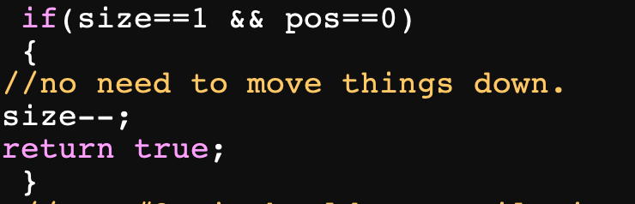

Fourth error: This error was also in the remove() method. Timmy had the for loop iterating while i was less than size, when it should’ve been size – 1, as iterating through until size causes the index to go out of bounds. This error became apparent when my assert statement to remove a value kept failing, and I noticed that it was because the loop was going too far. 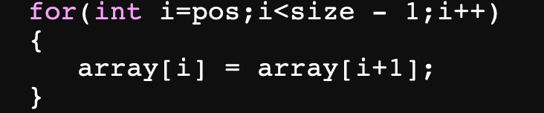

Fifth error: This error is in Timmy’s insertBefore method. In the original code, the for loop runs while i is less than position. However, since i is being decremented, it should instead run while i is greater than position given. I noticed this because the for loop wouldn’t run when I tried to add an element in the middle of the list, because i wasn’t less than the position. 